Problem 1)

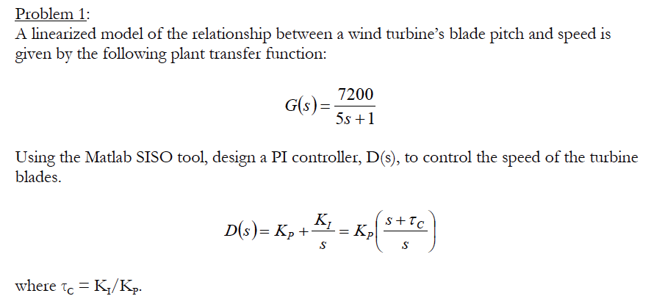

D(s)= $.0058\left(\frac{s+1.94}{s}\right)$

Kp=.0058, tc=1.94

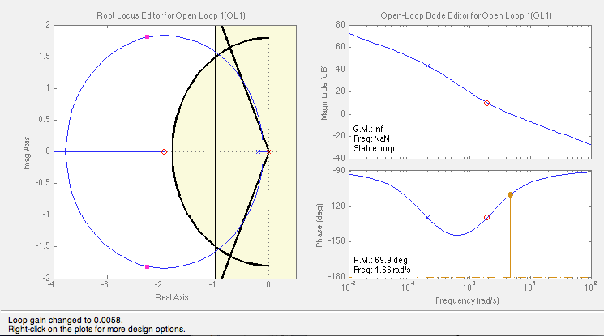

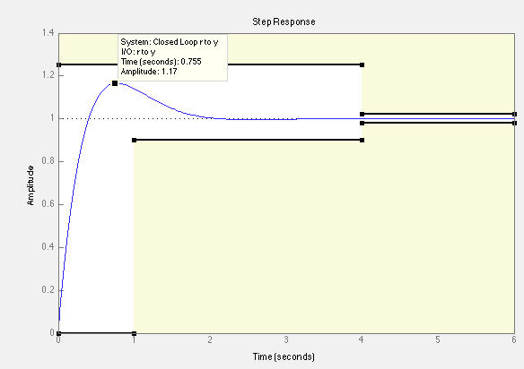

as can seen in the step plot above, the system meets all constraints

Mp=17%

tp=.755 seconds

tr=.323 seconds

ts=1.75 seconds

ess=0

Problem 2)

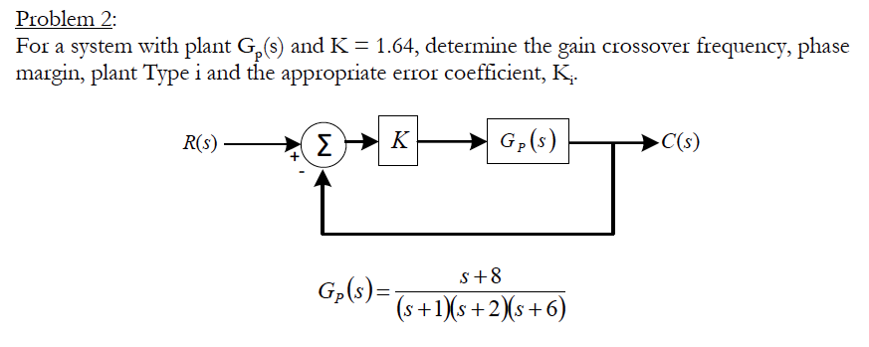

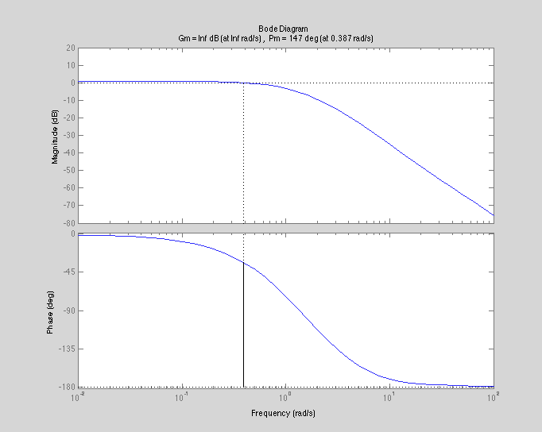

Phase Margin = 147 degrees

Gain Crossover Frequency

wc= getGainCrossover(sys,1)

wc=0.3874